**CHAPTER 1**

# INTRODUCTION

Many healthcare providers use computerized information systems to a certain extent. However, the problem of different information sources has impeded the health care information which is present in the health services. Information sharing on the different healthcare providers has been recognized as a developing area of significant because of the importance in modifying patient cantered and recurrent care. The implementation and construction of health information system is difficult due to the autonomy of different clinics also which is focused in a particular area, heterogeneity in ownership in clinics resulting differences in information systems that they facilitate. The occurrence of the Web Services enhances the opportunity to address the above challenges by using new solutions. This paper introduces an online patient appointment scheduling system with python and Django. Customer satisfaction has become a serious concern in today’s health care services and a number of innovations have been introduced to provide customer satisfactory. The healthcare service providers are concurrently experiencing in cost reduction and improve the access and quality of care they provide. Many healthcare institutions are engaged with long waiting times, delays, and queues of patients.

Typical questionnaire in hospital management include: How should they optimise the number of queues? How to effectively retrieve data from database based on individual blood group? How to include medication remainder to patient registered mail-id / calendar services?

Today, the health care system is a life-preserving community of people who have spent their careers following the evolution of health care industry and technology all around the globe, and explore the questions arising from all aspects of this complex enterprise. While looking towards the government hospitals especially in India, the waiting system is still boring and time consuming where the patients are unable to visit their doctor. Since there are many solutions for the time management yet they are not implemented on that situation. Our policy is to make it easy and more portable that helps the patients to visit its own specialised doctor in a stipulated time.

*Computer Science and Engineering* 1 *KMEA Engineering College*

## 1.1. FIELD OF INVENTION

Computers are being widely used in medical organisations. There are different hierarchy of interface of medicine and computer technology. Nowadays healthcare organisations uses computers in a more sophisticated way, and scientists are no longer required to analyse the data collected by computers in a research laboratory. Now a days, patients and doctors can access Web based portals to coordinate treatment plans and schedule appointments. Patients are also widely using mobile and miniature devices to stay on regular monitoring important information such as heart rate and blood pressure to lead a healthy lifestyle.

Reebok established by computer science / IT specialist depends on their task as a work. Researchers who works in university laboratories and hospitals I usually the one who makes a breakthrough technology for an outrages problem that usually get publishing science journals which becomes useful for others. This work is mostly theoretical and explains a context towards practicality funding of such projects bring it to next level making it available as an solution to a problem which used to exist.

Medicine and healthcare are two of the most important part of our human lives. Traditionally, medicine solely relied on the discretion advised by the doctors. For example, a doctor would have to suggest suitable treatments based on a patient’s symptoms. However, this wasn’t always correct and was prone to human errors. However, with the advancements in computers and in particular, Data Science, it is now possible to obtain accurate diagnostic measures. There are several fields in healthcare such as medical imaging, drug discovery, genetics, predictive diagnosis and several others that make use of data science. A good medical history will include health information from you and close family. Risks for diabetes, heart disease, and several types of cancers can be genetically inherited. While this doesn’t mean you’ll become ill, you can plan accordingly. Doctors may recommend more frequent mammograms for patients with a family history of breast cancer, for example. It can also be a good guide for lifestyle changes, such as quitting smoking or increasing exercise.

Surprisingly, when asked by doctors, most people give incorrect information on their medication lists. It’s not your fault if you don’t remember everything. Your medical records, though, provide an easy way to keep track of your medicine. Both prescription and over-the-counter medications,

*Computer Science and Engineering* 2 *KMEA Engineering College*

like painkillers, should also be included. A study showed that patients with access to their medical records were better at regularly taking medication as prescribed. Your medical history isn’t just for your benefit. You can use it to alert other family members of their predisposition to getting certain diseases. Be sure to update your family history as children are born or if family members develop illnesses. After you add them, inform your doctor of the changes. This could be a valuable tool for the generations yet to come. For the patient, it helps to be informed when you go to the doctor. You can ask the right questions and feel more secure in your care. When there’s limited time, your medical information could mean the difference between life and death. Touch of care make sure you have the right information on hand at the right time, wherever you are.

## 1.2. GENERAL BACKGROUND

Based on Hospital Management System, implementation needs to be accurate and explicit, the clinic management system provides certain automation of many vital daily processes. The hospital system software covers the services that unify and simplify the work of healthcare professionals as well as their interactions with patients. There is always the wide choice of features that can be included in the system. Moreover, the most important thing they are created to streamline various procedures that meet the needs of all the users. The hospital management system feature list is concentrated on providing the smooth experience of patients, staff and hospital authorities. It might seem that their expectations differ, they still are covered by components of the hospital information system. Quality and security still remain the main criteria of the medical industry. It is also known for the constant and rapid changes to improve the efficiency of medical services and satisfaction of the patients.

Depending on the hospital management system software features, it can deal with a lot of tasks. It helps to outline and implement policies, guarantee communication and coordination between employees, automate routine tasks, design the patient-oriented workflows, advertise services, manage human and financial resources and provide the uninterrupted supply chain. The components of a hospital information system can be chosen and combined in the general system that meets the needs and norms of the healthcare industry as well as quality standards. One of the

*Computer Science and Engineering* 3 *KMEA Engineering College*

main requirements of the clinic management system is security. All medical records have to be

protected and only accessible for the allowed users. The convenient and informative interfaces should correspond to their roles and responsibilities in order to protect the confidential data. hospital management system design class of medical information solution that focuses mainly on to the organizational need of hospital as well as patient comfort. an hospital management system is a computer web-based application that manages the functioning of a hospital. The system is designed to manage all the necessities of the hospital such as administration medical history patient details appointment etc.

Hospital management system includes multiple organization branched into a common interface so that if patient consult a doctor in different organization the medical history can be retrieved easily. Hospital management system provides a secure storage of data to access it from anywhere at any time hospital management system is essential for all health care establishments such as hospital, nursing home, health clinic, dispensaries etc.

Benefits of implementing hospital management system

1. Appointment booking
   * + helps patient cut the long queue and save their time
     + Equipped with features like automated email
2. Role based access control

• Allows employees to access only the necessary information for their effective performance

1. Overall cost reduction
   * + Cut down paper cost because everything is computerized
     + No separate cost for setting up physical service

*Computer Science and Engineering* 4 *KMEA Engineering College*

1. Data accuracy
   * + Remove error made by humans
     + Alerts during shortage of stock

1. Data security
   * + Keep the patient record private
     + Restrict access through role based access control
2. Revenue management
   * + Make the audit simple
     + Helps with the statistics and other aspects

*Computer Science and Engineering* 5 *KMEA Engineering College*

# CHAPTER 2

# LITERATURE SURVEY

In [1] Priyanka Patil describes a web-based medical management which includes patient database in cloud. It conveys the idea about cloud storage as well as android programming technology which act as the main functions in online medical management. Patient management and other customized application can be seen through tablets using android programming. Later the doctors can investigate through the reports and prescribe medicine. As many web services are made available online, almost every field is made online, web-based applications can provide a boon to hospital management. The system should incorporate many things online that include the following Most importantly maintaining the patient’s records in details including his disease, history, reports etc. which the doctor can access from anywhere using his login. The online storage can be implemented using cloud computing which provides a shared and secured access to all the resources shared. Web based technology offers many online services in almost every field. It reduces the number of tasks, cost, and efforts to a greater extent using cloud computing. The paper describes about an idea of web-based platform that make many medical/hospital procedures online using Cloud. This will help in management of patients, managing the schedules of the doctors, maintaining the records of patients which can be accessed throughout hospital. It includes storing, managing, communicating, analysing and updating the patient details online. Each doctor can be provided with a tablet with the customized version of this application specific to their specialty using android programming. Thus, by implementing this web-based application using cloud computing time consuming and inconvenient.

Normally Users are not aware about all the treatment or symptoms regarding the particular disease. For small problem user have to go personally to the hospital for check-up which is more time consuming. Also handling the telephonic calls for the complaints is quite hectic. Such a problem can be solved by using medical Chabot by giving proper guidance regarding healthy living. The medical chat-bots functioning depends on Natural language processing that helps users to submit their problem about the health. The User can ask any personal query related to health care through

*Computer Science and Engineering* 6 *KMEA Engineering College*

the chat-Bot without physically available to the hospital. By Using Google API for voice-text and text- voice conversion. Query is sent to Chabot and gets related answer and display answer on android app. The System’s major concern behind developing this web based platform is analysing customer’s sentiments.

In [2] Fatma Poni Mardiah suggests an online appointment system to reduce the waiting time using

Queue Theory. Main aim is to justify the major causes of patients’ length of time for medical treatment in a clinic and how to maximize the effectiveness and efficiency of resource and capacity. The hospital queue model uses single-channel multiphase systems. Generally, Queuing theory is the tool to look at patient waiting times on each server separately. The results are shown and hence the hospital should change the appointment system for patients. Customer satisfaction has become a serious concern in service sector. On Healthcare industry, a number of initiatives have been introduced to enhance customer satisfaction. The healthcare industry providers globally are experiencing increasing pressure to concurrently reduce cost and improve the access and quality of care they deliver. Any healthcare institutions are confronted with long waiting times, delays, and queues of patients. Practical issues such as the ease of use of the appointment system, or implications on modifying physicians’ behaviour need to be considered in order to achieve the ultimate goal of improving “real systems”. It may also be interesting to determine what are the most commonly used appointment system in practice. There is a lack of emphasis on the real-life performance of appointment system implemented as a result of studies. The hospital queue model uses single-channel multiphase systems. Queuing theory be the first tool to look at patient waiting times on each server independently. The results show that the hospital should change the appointment system for physicians. Applying ‘doctor on call’ system may appear to reduce doctor’s idle time but lead to high patients’ waiting times. In some cases, the appointment system make doctor to be back and forth to the hospital, so it was not directly affecting the productivity of a doctor.

Developed system is a comprehensive, integrated information system designed to manage the administrative, financial and clinical aspects of a hospital. As an area of medical informatics, the aim of the system is to achieve the best possible support of patient care and administration by

*Computer Science and Engineering* 7 *KMEA Engineering College*

electronic data processing. This encompasses paper-based information processing as well as data

processing machines. Laboratory information system is a class of software which handles receiving, processing and storing information generated by medical laboratory processes. People generally do not know the procedures in hospitals. They do not know which department they should go for their specific medical complaints. So an intelligent system is required to assist them. Patients will initially be registered in the system with a friendly question and answer menu. Once registration is completed, they will select their medical complaints through a software menu. The menu driven software will present the patient with the right department, doctor name, appointment date and time, possible medication and laboratory tests subject to doctor’s confirmation. Doctors examine the information provided by the patient and confirm the data once they examine the patient.

In [3] Xiaojun Zhang explains an online patient appointment scheduling system based on the Web Services architecture. The online appointment system was developed and installed in the CHC. There is a web link at the home page of the medical centre Web site, by clicking on it allows the person to enter the web-based details to the online appointment system. The traditional system of preserving health records has been pen to paper based and then to the computerized storage in hospitals in present times. However, this paper-based system is still very tedious and the patient needs to keep all his medical reports, test scans, bills and case files intact and in place for every single doctor. And most of times, the patient or even the hospital authorities end up misplacing, tampering or damaging these records due to various reasons. The digitization of health records using Internet of Things (IoT) wherein an intelligent device like a smart card or a smart drive is converted into a portable web server. This facilitates not only the easy storage and procuring of records but also serves the purpose of remote diagnosis and treatment (through video calling module) in various alarming and uncalled emergencies. Internet of Things (IoT) can be described as a smart network of devices that are interconnected and embedded with sensors and software used to collect data and exchange information. The IoT has a variety of application domains, including health care as one of its chief research areas. Our project eliminates the traditional system of preserving patient’s medical health literature by introducing a portable web server which stores

*Computer Science and Engineering* 8 *KMEA Engineering College*

and synchronizes all kinds of patient information (reports, findings, scans, prescriptions, medical history, etc.) thereby making the system go paperless and hassle free. Further, this paper demonstrates the various functionalities implemented in order to devise portable medical records and discusses on the scope of the core idea in the near future revolutionizing the field of healthcare.

In [4] Fayezah Anjum develops and provides an efficient way of storing information electronically based on an online health care system. It also gives a faster communication mechanism between patients and doctors, and also ensures better security for the users. The main intension of introducing the system is to achieve location transparency for patients and doctors in the existing traditional health care system. At the same time it helps to reduce the manual paper work at the healthcare counters. As we deal with sensitive domain, there was also a need to handle the data in a secured way hence different levels of security measures were adopted. User friendly interface and quick data processing and transmission were also the demand of application. The application developed has met all the objectives such as online video conferencing, emergency alarm with critical form of medical condition or accidents, online medical prescription, scheduling appointment, information about nearest hospital and life remainder system to remind medicine intake timely. By deploying the application on mobile phones, we have been able to bring the healthcare App on the palm of every individual. The application can be deployed on the cloud by integrating different hospitals and linking their servers through the cloud. Though sufficient security measures have been adopted still there could be a scope to increase the security parameters.

With respect to the feedback of the App users’ further improvements can be incorporated within the system to make it more users friendly.

In [5] D.V. Chandran has main intension to develop a system that can achieve location transparency for patients and doctors in the existing health care system. It consists of GSM,GPS, Video conferencing and a report transfer system which facilitate faster and coherent communication between doctors and patients giving transparency to locations and distance while using the application. In today's world everything is becoming computerized and web based. Different organizations have already moved towards computerized systems which made lives

*Computer Science and Engineering* 9 *KMEA Engineering College*

easier and faster. One of the most important sectors of any nation is their health care sector. The organization of people, institutions and resources that deliver services related to health to meet the medical needs of the general public or any individual is referred to as Health Care System. Online Health Care (OHC) system, users can register as patients to store their medical data in the database and it can access it anytime, from anywhere The system also consists of registered doctors under the enlisted hospitals, who can give free medical advice and prescribe necessary medications to the patients when requested for an appointment. The appointed doctors can view the patient's data and listen to patient's health complain via message system and issue prescription. This is a two-way communication between patients and doctors over the online health care system.

In [6] Aakash Chatline discuss on various functionalities which makes portable medical devices using Internet of things. It shows various networks and eliminates traditional health care system. Further, this paper explains major technologies implemented in order to access the portable medical records and elaborates on the core idea in the near future revolutionizing the field of healthcare code is now being widely used in a variety of businesses. QR code is a way of encoding more information than a traditional bar code. And most importantly, it contains information that can be easily decoded at high speed. In this paper, we show how to create the QR codes via the web browser that facilitates users to easily create their own QR codes for websites, emails, business cards, print ads and so on. The proposed method was developed using entirely open source software such as Libqrencode, Drupal and Ubuntu. The experimental results show that the QR codes were successfully and correctly generated. Therefore, the proposed method is considerably a QR code generator collaborative tools that is available for free use. QR Code is two-dimensional barcode which is categorized in matrix barcode that can store data information. Mobile phones with built-in camera are wildly used to recognize the QR code. Google is the first introduced URL shortening service that provides automatically generates QR codes. QR Code has been approved as an AIM Standard, a JIS Standard and an ISO standard. QR Code contains information in both the vertical and horizontal directions whereas a bar code contains data in one direction only. QR code is now being widely used in a variety of businesses.

*Computer Science and Engineering* 10 *KMEA Engineering College*

In [7] Phaisarn Sutheebanjard describes the context in QR code generator. It simply stands for Quick Response where we can see them on posters, magazine ads, websites. While the ability to create QR codes via URL is not absolute in any sense, it is a fun feature that should increase interest with QR codes, which gain popularity among marketers. It shows that the Web Services architecture provides an appropriate paradigm for the development of an integrated health information system which enables the communication among heterogeneous, autonomous and distributed healthcare information systems. The prototype system demonstrates the feasibility of the architecture. The future work will be focused on integrating the new clinical applications into the system. This case study serves as a preliminary study for the future analysis of consumer’s acceptance and usage of eHealth applications, such as PCEHR in primary health care. Future statistical analysis of qualitative and quantitative results will be undertaken to improve our understanding of the patient’s behaviour in adopting e-health application and the factors that impact on the adoption behaviour. Our preliminary findings are highly valuable for the decision makers charged with the responsibility of implementing PCEHR to consider in designing their strategies and plans for the introduction of the PCEHR system.

Currently, many healthcare providers in primary health care use computerized information systems to a certain extent. The design and implementation of integrated health information system is challenging due to the heterogeneity. The main clinical system, which is mainly used by GPs, is installed on the Windows Server platform. The allied health practitioners use a different system installed on the Linux platform for patient scheduling and medical recording. These two clinical information systems are operated separately by practitioners with different workstations.

*Computer Science and Engineering* 11 *KMEA Engineering College*

# CHAPTER 3

**PROJECT OBJECTIVE**

**3.1. OBJECTIVE OF THE PROJECT:**

The main objective of our proposed project is to build a website and app for a Hassle free and easy hospital experience, major features include complete centralizing of the hospital patient data, decrease the work that is done manually at Hospital, help in reducing lots of paper work and file work in these hospitals. Latest information is always available to the admin. People can be updated real time with their respective enquires, providing a platform for charity and medical emergency.

The main idea behind hospital software development is to improve the facility’s workflow and boost customer satisfaction. A hospital web-app can help people find doctors, organise their appointments, and receive the treatment they need. It can also reduce or simplify administrative tasks for physicians and boost collaboration inside medical teams a long-term advantage for both the hospital’s reputation and treatment results. Having digital record of your medical history makes it easy and quick for the further proceeding of the hospital findings and can start the treatment as quick as possible without any unnecessary repeated test which would have taken recently doctor having access to the medical history can significantly increase the chance of patient survival during the trauma time of a patient where only the most unfavourable option remains as a result.

In a hospital there may be different situation that can arise which may be un predictable during most of the time in such environment having document is a real pain to follow up and the complete transparent information of their medical data is not acknowledge to the patient from doctor as there may be interpretation in recalling the memory after the entire proceeding in most of the trauma cases. Touch of care works perfect in such challenging environment by lifting the work of having a structured data entry of the treatment as it is done on the go with an easy to understand UI from the doctor portal. In the future there may be changes that organisation collectively may prefer and on such occasions the challenges to the web application can be made easily without any super professional developer the entire project touch of care is built in Django and the most popular

*Computer Science and Engineering* 12 *KMEA Engineering College*

programming language python which has a huge open source support which guarantees the most advance features can be added with no much effort.

Touch of care focus on the organisational policies as well as patient comfort with managing their medical data with the most effective manner to have a proper lifestyle decision that live their life to the fullest.

The implementation of hospital management system project provides the institution with different advantages that improve the service quality and efficiency. It is created for three groups of users: patients, hospital staff and management, and third-parties like drug suppliers and insurance companies. The interaction between them conveys the general performance. The benefits received by a certain group of users also positively influence the work of the others.

Cooperation and communication are the fundamental requirements here.

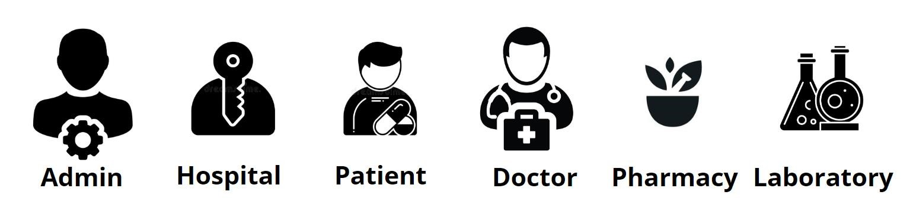

Fig.3.1. Fundamental Requirements

In order to create the hospital management system feature, we need to identify the priorities by choosing the benefits that are prior for our case.

1. Improve Processes
2. Digital media records
3. Financial control and tax planning
4. Market strategy
5. Insurance claims processing
6. Less time consuming
7. Patient self-service
8. Better customer Experience

*Computer Science and Engineering* 13 *KMEA Engineering College*

**3.3. SCHEME OF THE PROJECT**:

1. Improved Processes

Automation is one of the main benefits here. It helps to optimize the user experience. Medical specialists, patients, and hospital authorities can interact online, make the appointments and exchange information.

1. Digital medical records

The hospital database includes all the necessary patient data. The disease history, test results, prescribed treatment can be accessed by doctors without much delay in order to make an accurate diagnosis and monitor the patient’s health. It enables lower risks of mistakes. c) Staff interaction

It is vital to engage all of your employees for improved coordination and teamwork. They do not need to make special requests and wait for a long time for an answer. Each specialist will be in charge of certain process stage and can share outcomes with colleagues just in one click. d) Facility management

Hospitals authorities are able to manage their available resources, analyse staff work, reduce the equipment downtime, optimize the supply chain, etc. Another fact to mention is that hospital staff deal with the digital data instead of endless paperwork.

1. Financial control and tax planning

The management has the ability to monitor different financial operations including expenses, profits, and losses, paying bills and taxes, in and outpatient billing. The financial awareness helps to analyse business prospects quite clear and move in the right direction.

*Computer Science and Engineering* 14 *KMEA Engineering College*

1. Market strategy

Due to the high market competitive nature, the medical industry is also open to all the different innovations that enable communication between patients, doctors, suppliers, and marketing services providers.

1. Insurance claims processing

Integration with health insurance services improves the experience of the patients and brings benefits to the institution. It allows you to be innovative and helps both the patient and hospital to handle many aspects of the insurance process successfully.

1. Less time consuming

As the services and interactions are improved in all possible ways, everything is being planned with greater precision. It saves the time of all the system users and provides them with up-to-date information.

1. Patient self-service

Patients have their own system accounts where the list of various actions can be performed. They are able to make online requests or reservation, receive the test results, receive the consultation of the medical specialists and many more.

1. Better customer experience

Since the clinic management system is patient-oriented, the treatment process can be less stressful. Doctors have more time for the examination and interaction with patients. In addition, all the requested information can be received online.

## 3.4. SCOPE

Touch Of Care organizes the stable functioning of daily tasks and interactions. This is a special tool to support the smooth operating of the software components that are vital for the

*Computer Science and Engineering* 15 *KMEA Engineering College*

clinic administration. The hospital records management software keeps a track of all the operations, stores the users’ data, performs its analysis and generates the reports. The medical institution is given the opportunity to collect its information in one place. It includes the patient and doctors’ records as well as the data concerning financial affairs, supply management. Furthermore, it is only processed, classified and accessible for authorized users. The hospital database management system provides users with data security due to all regulations. Implementation of different functions empowers smooth and clear functionality.

Touch Of Care organizes the stable functioning of daily tasks and interactions. This is a special tool to support the smooth operating of the software components that are vital for the clinic administration. The hospital records management software keeps a track of all the operations, stores the users’ data, performs its analysis and generates the reports. The medical institution is given the opportunity to collect its information in one place. It includes the patient and doctors’ records as well as the data concerning financial affairs, supply management. Furthermore, it is only processed, classified and accessible for authorized users.

The hospital database management system provides users with data security due to all regulations. Implementation of different functions empowers smooth and clear functionality. Many healthcare providers use computerized information systems to a certain extent. However, the problem of different information sources has impeded the health care information which is present in the health services. Information sharing on the different healthcare providers has been recognized as a developing area of significant because of the importance in modifying patient centered and recurrent care. The implementation and construction of health information system is difficult due to the autonomy of different clinics also which is focused in a particular area, heterogeneity in ownership in clinics resulting differences in information systems that they facilitate. The occurrence of the Web Services enhances the opportunity to address the above challenges by using new solutions. This paper introduces an online patient appointment scheduling system with python and Django. Customer satisfaction has become a serious concern in today’s health care services and a number of innovations have been introduced to provide customer satisfactory. The healthcare service providers are concurrently experiencing in cost reduction and improve the access and

*Computer Science and Engineering* 16 *KMEA Engineering College*

quality of care they provide. Many healthcare institutions are engaged with long waiting times, delays, and queues of patients. The main features include the filtration of each individual from database according to hospital need and notify them in their notification panel when required for situations like epidemic outbreak, donor finding etc. even a remainder for medication is provided by mail / calendar service for patient convenience. There is also an activity wall which mentions interesting activities of nearby hospitals, health care organisation details and an emergency section where the requirement of the hospital can be displayed such as donors.

Touch of care is built to reduce the gap between health care service and people, it introduces a common platform which is web based with different operating interfaces for hospital, pharmacy and clinical laboratories bringing all these together into a common platform can impact the efficiency of the entire hospital as well as patient service positively.

*Computer Science and Engineering* 17 *KMEA Engineering College*

**CHAPTER 4**

**METHODOLOGY**

## 4.1. EXISTING SYSTEM

Current hospital managing web application have a very narrow proximity towards data that is being stored within a single organisation. Existing medical technology towards this data is not uniform they are stored in an unstructured manner which is very much complicated and impossible to retrieve with the pace at which the information is needed. Each organisation has their own individual system with an individual workflow which is not a unified which can lead to complication in handling and it will be biased in favour to the organisation and its policies. Existing web application related to hospital management focuses more towards the organisation comfort and policies there are no system which sees through the context of a patient’s eye and comfort. The main challenging aspect of current system is that they are of high maintenance with high experienced technical organisation for the smooth running of these web application. Any modification or immediate requirement in the application requires a full catalogue of protocols which the sharing organisation are biased to follow which is time consuming and disadvantage in this dynamic environment. As long as each stage implementation needs to be accurate and explicit, the clinic management system provides certain automation of many vital daily processes. The hospital system software covers the services that unify and simplify the work of healthcare professionals as well as their interactions with patients. There is always the wide choice of features that can be included in the system. Moreover, the most important thing they are created to streamline various procedures that meet the needs of all the users. The hospital management system feature list is concentrated on providing the smooth experience of patients, staff and hospital authorities. It might seem that their expectations differ, they still are covered by components of the hospital information system. Quality and security still remain the main criteria of the medical industry. It is also known for the constant and rapid changes to improve the efficiency of medical services and satisfaction of the patients.

*Computer Science and Engineering* 18 *KMEA Engineering College*

Hospital management has greatly changed over the last decades. Business expertise, modern technologies, connected devices, mobile apps, and knowledge of healthcare are key elements for the implementation of hospital management system project. The number of healthcare providers has increased and the patients have a wide choice of medical specialists. The interactions between the hospital and the patient can be simplified for the convenience of both sides. Each institution has the opportunity to create the efficient, clear and fast delivering healthcare model.

Depending on the hospital management system software features, it can deal with a lot of tasks. It helps to outline and implement policies, guarantee communication and coordination between employees, automate routine tasks, design the patient-oriented workflows, advertise services, manage human and financial resources and provide the uninterrupted supply chain. The components of a hospital information system can be chosen and combined in the general system that meets the needs and norms of the healthcare industry as well as quality standards. One of the main requirements of the clinic management system is security. All medical records have to be protected and only accessible for the allowed users. The convenient and informative interfaces should correspond to their roles and responsibilities in order to protect the confidential data.

Since the purpose of the hospital information system is the arrangement of necessary, precise and appropriate data, the hospitals should ensure the system work and can be accessed at any time. The online hospital management system and desktop (on-premise) solutions are possible options of the healthcare providers. This could be a unique system for the certain institution, chain of clinics, state hospitals or even the international medical organizations. It is usually started with the basic version that can be scaled up.

The hospital management system organizes the stable functioning of daily tasks and interactions. This is a special tool to support the smooth operating of the software components that are vital for the clinic administration. The hospital records management software keeps a track of all the operations, stores the users’ data, performs its analysis and generates the reports. The medical institution is given the opportunity to collect its information in one place. It includes the patient and doctors’ records as well as the data concerning financial affairs, supply management, etc.

*Computer Science and Engineering* 19 *KMEA Engineering College*

Furthermore, it is only processed, classified and accessible for authorized users. The hospital database management system provides users with data security due to all regulations. Implementation of different functions empowers smooth and clear functionality.The hospital records management software tracks the number of available doctors and their working hours. This allows to have the accurate schedule of each employee, manage your facility abilities and the supply chain in order to meet all the needs of the patients. It helps to arrange the appointments for both the staff and patients’ convenience.

Any clinic should store medical histories, test results, prescribed treatments, etc. The good hospital database management system will do it for you. All the details are securely stored for the access of the doctor and can be provided to the patients by their requests. They can receive the test results or medical reports by email or the user account. When the written form is required, printing will take only a few minutes for the clinic staff.

Another function is connected with managing finances. The hospital accounting software estimates the patients’ payments. It might remind the bank account where you can check performed operations and the billing status of each customer. Moreover, the hospital record management system is capable of generating regular reports of the tracked data including healthcare, staff efficiency, finances, inventory, and facility utilization, etc. This greatly helps the clinic authorities in making reasonable policy decisions. Therefore, any of these functions are designed to make the clinic management system easy to use, comprehensive, powerful and reliable.

The purpose of developing Hospital Management Software to manage the quality and management tasks at a hospital or health care clinic. Hospital management software helps you refined the process of enhanced patient care, and safety. In this age when Pandemics like Covid-19 and other diseases are spreading, the software help doctors handle patient details and track disease history on the cloud-based applications. Hospital management software features numerous important benefits that help in the sleek working of the day to day activities of a clinic. Software designed in such a way that it manages the patients that are under observation, the patients that are discharged from hospital, data source of victims, billings, hospital information such as doctor’s availability, their capacitation, the expenditures procedure and expenses to several employees. MediSolz Clinic

*Computer Science and Engineering* 20 *KMEA Engineering College*

Management Software is one of the best software that offers several features and facilities which allow doctors at a clinic to concentrate at the patients more deeply. Such clinic management software has the aim that let the clients change the facts of the numerous patients and physicians and unified security procedures that avoid neglect of the saved information

**4.1.1. Drawbacks of Existing System**

1. Current system focuses only the organisational policies and protocols. The data stored are within an individual organisation.
2. Each data stored by each individual organisation are in their individual database hence the advantage is limited.
3. Current web application system which manages hospitals are not capable of bringing the entire medical services into a single platform.
4. Expert programmers are required to handle any changes for future evolution.

5.Maintenance up current system is expensive and not very efficient

6.Existing Hospital managing web application system only managers the particular organisation which it is made for hence the data stored unstructured which makes it difficult to retrieve.

## 4.2. PROPOSED SYSTEM

The main objective of our proposed project is to build a website and app for a Hassle free and easy hospital experience, major features include complete centralizing of the hospital-patient data, decrease the work that is done manually at Hospital, help in reducing lots of paper work and file work in these hospitals. Latest information is always available to the admin. People can be updated real time with their respective enquires, providing a platform for charity and medical emergency. the most objective of our project is to create a web page and app for a problem free and simple

*Computer Science and Engineering* 21 *KMEA Engineering College*

hospital expertise, major options embrace complete centripetal of the hospital-patient knowledge, decrease the work that's done manually at Hospital, facilitate in reducing innumerable paper work and file add these hospitals. Latest information is often offered to the admin and the individuals will be updated real time with their various enquires, providing a platform for charity and medical emergency. The implementation of hospital management system provides the establishment with totally improved the service quality and potency. It’s created for 3 users: patients, hospital employees and management, and third-parties like drug suppliers and insurance corporations and overall is controlled by the admin. The interaction between them conveys final performance.

This project initially deals with a user portal for every module in its own different context. Each individual user has to login to interact with project UI. Once a new patient registers into our web interface they are provided with a QR code. Now this QR code can be used to access in variety of hospital facilities throughout the journey. Patient portal provided with useful features like health status, medicine timing, medicine history and lab reports. After successful registration patient can access these features in there portal by login with their username and password. In similar context to the patient portal, doctor can access patient database with the QR code provided to the patient during registration. Here doctor can directly access patient database just to insert prescriptions, special notes, symptoms and send request for lab test to laboratory through patient QR code. Doctor login with universal doctor id along with their unique username and password. Doctor can only access the portal at hospital working hours. Our project deals with the dynamic situation that arise in the hospital premises especially around laboratories and pharmacy. In laboratory their portal handle with uploading patient lab reports into the patient database. Here patient is identified using the unique QR code that each individual owns. The lab tests are performed from the request by the doctor through the patient portal. Once the report is being uploaded this can be viewed by the patient and can be observed by the doctor in the next visit. In the busy environment of pharmacy for the patient convenience, once the doctor prescribes medicines to the patient database, a request to send in prior to pharmacy for as to avoid chaos. Pharmacist can organise and keep the prescribed medicines before the patient arrive. Patient are identified with the unique QR code that they own. Admins are responsible for the entire working of the hospital.

*Computer Science and Engineering* 22 *KMEA Engineering College*

# 4.3 SYSTEM ANALYSIS AND DESIGN

The software requirements are description of features and functionalities of the target system. Requirements convey the expectations of users from the software product. The requirements can be obvious or hidden, known or unknown, expected or unexpected from client’s point of view. Software requirements are focused towards goal of the organization. This study analyzes whether the software product can be practically materialized in terms of implementation, contribution of project to organization, cost constraints and as per values and objectives of the organization.

If the feasibility report is positive towards undertaking the project, next phase starts with gathering requirements from the user. Analysts and engineers communicate with the client and end-users to know their ideas on what the software should provide and which features they want the software to include.

Our basic Software and Hardware requirements are listed below:

|  |  |
| --- | --- |
| 1. Processor | Intel Pentium IV 2.4GHz or above |
| 2. Clock speed | 700 MHz |
| 3. System bus | 32-bit PCI Ethernet Card |
| 4. RAM | 4 GB of RAM |
| 5. HDD | 100 GB or higher |

Tab.4.1: Hardware Requirements

*Computer Science and Engineering* 23 *KMEA Engineering College*

2 SOFTWARE REQUIREMENTS:

|  |  |
| --- | --- |
| 1. Operating System | Windows 7/higher  (client or server) |
| 2. User Interface | HTML, CSS , |
| 3. Client – side scripting | Java script |
| 4. Programming Language | java , Python |
| 5. Web Framework | Django |

### Tab 4.2: SOFTWARE REQUIREMENTS

1. Python

Python is a high level, object oriented, interpreted, general purpose programming language with dynamic semantics. It is very attractive to rapid applications due to its high-level built-in data structure, combined with dynamic typing and dynamic binding as well as it is also used to connect existing components together. It reduces the cost of program maintenance due to its easy learnable syntax.

Python is easy to use, powerful, and versatile, making it a great choice for beginners and experts alike. Python’s readability makes it a great first programming language — it allows you to think like a programmer and not waste time with confusing syntax

*Computer Science and Engineering* 24 *KMEA Engineering College*

1. Django

It is an advance web based framework written in python that make use of the model view controller architecture pattern, it had been created during a fast paced newsroom environment and its key objective is to ease the development of complicated , database driven website, it is available as an open source web frame work and uses python extensively to create files ,settings and data models it was mainly focus to solve two main challenges, the desperate requirement of highly expertise web developers and the intense deadlines of busy work environment .it concentrates more on automating possible areas.

With Django, you can tackle projects of any size and capacity, whether it’s a simple website or a high-load web application. It’s fully loaded with extras and scalable, so you can make applications that handle heavy traffic and large volumes of information. It is cross-platform, meaning that your project can be based on Mac, Linux or PC.

It works with most major databases and allows using a database that is more suitable in a particular project, or even multiple databases at the same time

1. SQLite

SQLite could even be a process library that implement a self-contained, zero configuration, server less, Transitional SQL database engine. The source code exists in public domains and is free for both private and commercial purposes. It has binding to several programing languages like C, C++, java, C#, and as for our requirement it has binding towards python also SQLite is ACID compliant (A- atomicity, C- consistency, I- isolation, D- durability).

SQLite is file-based — the database consists of a single file on the disk, which makes it extremely portable and reliable. Although it might appear like a “simple” DB implementation, SQL is used in SQLite. SQLite is meant to be great for both developing and testing and offers more than what is needed for development.

*Computer Science and Engineering* 25 *KMEA Engineering College*

## 4.4. PROJECT MODULES

Module is a logical separation of a functionality within a project.

We can have as many modules in an application, they are basically used for reusability and better code maintenance. In our project, there are 6 modules:

* ADMIN
* HOSPITAL ADMIN
* DOCTOR
* PATIENT
* LABORATORY
* PHARMACY

Proposed application for rescue operation modules are provided below:

1. Admin

Admins are those who have the privilege to make changes in the main database they can retrieve any information, update information, remove information, and they can even check the current status and control the entire database. They are the one who add the hospital admins. Here each individual can book their OP tickets from their home with a quick registration providing them with a QR code which can be later used for easy access to different facilities. Once a patient books their appointment with doctor, they are provided with an estimate time and also patients will be provided with the real time update of doctors online. admins are the one with the name privileges to control the different organisation which comes under the entire application. Who approves for an organisation to be a part of the web application alter the data with the specific protocol for better utility. Admins have a privilege to approved for the organisations that is added to the admin portal, also approve for the doctor’s laboratory and pharmacies outside the organisational proximity

*Computer Science and Engineering* 26 *KMEA Engineering College*

1. Sub-admin

Hospital Admins(fig.3.1) are those who have the privilege to add hospitals, laboratories, doctors in the hospital and can control the appointment, and access the data of that hospital. Sub admin is responsible for the control over the particular organisational portal which they stand for. They have different privileges to manage the internal affairs in the organisation and have a key monitor over the overall status. Sub admins can add doctor’s lab technicians and pharmacist who works within the organisational proximity. Sub admins means have a wide dashboard where the working environment of the hospital such as number of doctors, lab technicians etc are available.

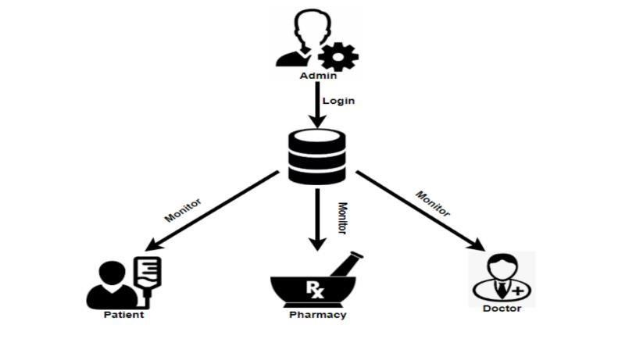

### Fig 4.1: ADMIN SYSTEM

3. Patient

Here when a patient registers them self, they receive a QR code which is unique for each individual(fig.3.2). They can use their profile and book their OP ticket after which they will be provided with an estimate time to reach hospital. People who come directly to hospitals can use there QR code to generate their OP ticket quickly. Even patients have the privilege to check the status of the doctor availability because doctor database is linked directly to their punching attendance system. Rewards are redeeming from hospital bills. All process is through QR code, so

*Computer Science and Engineering* 27 *KMEA Engineering College*

easily update it inpatient database. The app is used by patient for enquiry and book OP tickets. Also get real time update of doctor availability. Patient or the user are with the most benefit from this web application they can login or if they are new they can register by filling a simple form with the proper data for their own benefits after the proper registration a unique QR code is been generated and provided to the user which can be used across the web application in different stages for making the entire process simple and fast. This QR code can be used at the hospital is pharmacies and laboratory for identification purposes. Be patient / user can see the medical history, make a appointments

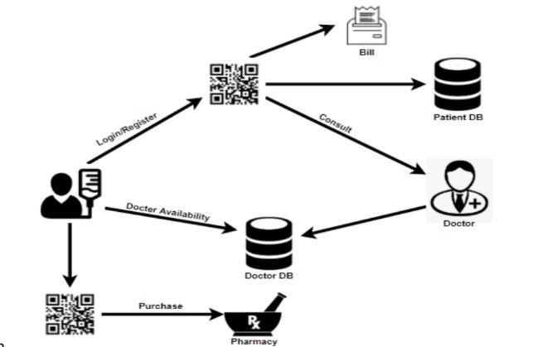

### Fig.4.2: PATIENT MODULE

4. Doctor

Once the patient enters the doctor room, doctor can access the patient database in which the medicines can be prescribed, after the session the information is send to the pharmacy along with patient detail (QR code). Once a patient leaves doctor gets updated according to the token number of next patients. If one patient not consult doctor then doctor can skip the profile, when he/her came doctor can recollect it. The doctor prescribes the medicines online and the details are share directly to the pharmacy in the hospital. The patient just has to show the QR code for verification

*Computer Science and Engineering* 28 *KMEA Engineering College*

at the pharmacy counter. In case if the medicine is not available in hospital, the printout of the remaining medicine is provided which can be used to buy from outside. If patient wish to go paperless then the patient can get the entire details online from his/her database.

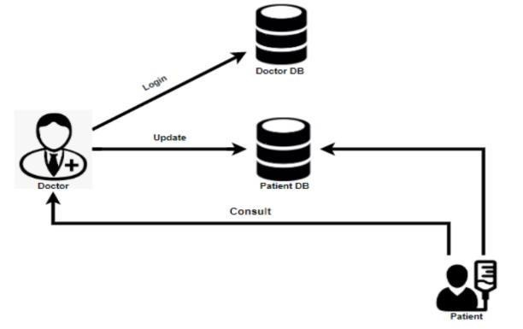

### Fig 4.3: DOCTOR MODULE

1. Pharmacy

In pharmacy(fig.3.4), the medicine will be ready in prior for avoiding any queue at within the hospital, and medicines that are not available are mentioned to purchase from outside, if there are any lab test prescribed the result is updated into the patient database by the laboratory. Patient QR code is used to get doctor prescription for medicine and doctor prescribed lab checks. These lab reports(fig.3.5) are update inpatient data base for next visit. pharmacist who operate pharmacy can identify the patient with the unique QR code that has been generated during the registration process of each individual patience which is a unique code specially used to identify each individual. This your QR code can be used to view the prescription that is been prescribed by the doctor to the patient and this medical information are limited to the pharmacy that is the only prescribed detail can be viewed not the history.

*Computer Science and Engineering* 29 *KMEA Engineering College*

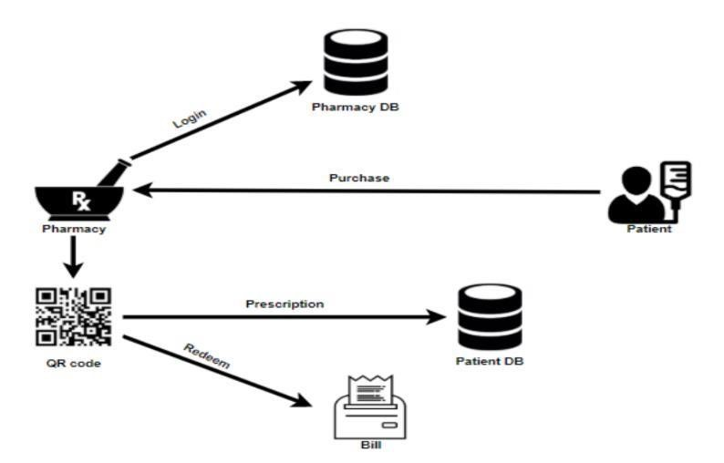

Fig 4.4: PHARMACY MODULE

1. Laboratory

In laboratory, similar to that of pharmacy they receive a request from doctor and the report is being uploaded to patient database for future investigation by doctors at prescribed visit. here also the can access the patient side by the QR code and patient name. Laboratory have it's on function which is similar to that of pharmacy here the technician who runs the laboratory can identify the patient with the QR code that is being generated during the registration process these unique code can give access limited information / recommendation by the doctor on the test that a patient must be performing on that laboratory . The technician at the laboratory after the proper test the result can be uploaded on to the database of the patient as in the form of PDF.

*Computer Science and Engineering* 30 *KMEA Engineering College*

### 

Fig 4.5: LABORATORY

BLOCK DIAGRAM OF HOSPITAL MANAGEMENT SYSTEM

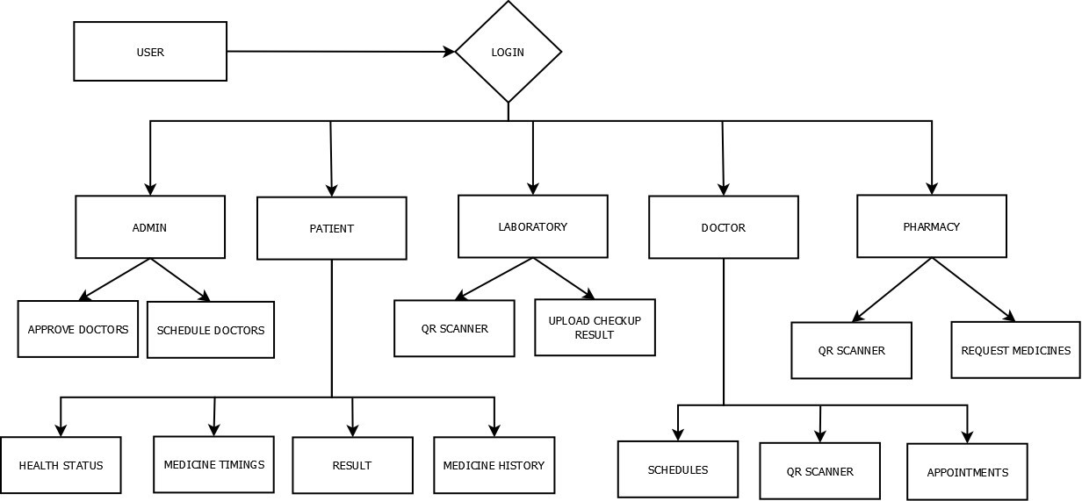

### Fig 4.6: BLOCK DIAGRAM

*Computer Science and Engineering* 31 *KMEA Engineering College*

In block diagram, it includes every fields with entire data base.

The main components are:

* Patient / user
* Admin
* Hospital admin
* Doctor
* Pharmacy
* Laboratory

This project initially deals with a user portal for every module in its own different context. Each individual user has to login to interact with project UI. Once a new patient registers into our web interface they are provided with a QR code. Now this QR code can be used to access in variety of hospital facilities throughout the journey. Patient portal provided with useful features like health status, medicine timing, medicine history and lab reports. After successful registration patient can access these features in there portal by login with their username and password. In similar context to the patient portal, doctor can access patient database with the QR code provided to the patient during registration. Here doctor can directly access patient database just to insert prescriptions, special notes, symptoms and send request for lab test to laboratory through patient QR code. Doctor login with universal doctor id along with their unique username and password. Doctor can only access the portal at hospital working hours. Our project deals with the dynamic situation that arise in the hospital premises especially around laboratories and pharmacy. In laboratory their portal handle with uploading patient lab reports into the patient database. Here patient is identified using the unique QR code that each individual owns. The lab tests are performed from the request by the doctor through the patient portal. Once the report is being uploaded this can be viewed by the patient and can be observed by the doctor in the next visit. In the busy environment of pharmacy for the patient convenience, once the doctor prescribes medicines to the patient database, a request to send in prior to pharmacy for as to avoid chaos. Pharmacist can organise and keep the prescribed medicines before the patient arrive. Patient are identified with the unique QR code that they own. Admins are responsible for the entire working of the hospital. They are the one who provide access to doctor, laboratory and pharmacy and can access patient’s database to filter out patients with parameter that is in context with situation.

*Computer Science and Engineering* 32 *KMEA Engineering College*

**CHAPTER 5**

# RESULT AND DISCUSSION

Our Project make a difference in current hospital situations. This project is perfect for such a dynamically challenging environment. Here this project is patient centric as well as organization friendly. It serves in both ways without any biasing. Our database filtering feature is one of the most requirement in our current era to monitor the disease outbreaks which happen unexpectedly. Each hospital has its own individual database managed by a admin which prevents any data breach. The unique QR code provided to each patients makes it easy to identify the patient at different services within the hospital. Bringing QR code into the project makes it easy for the patients to reduce effort of staying in long queue for consulting doctors. Web application will help the patient to view their lab reports and medicine notes. So that patient need not be aware about the written prescription and hard copy of lab reports. All these data are stored in the database hence can be viewed any time and future consultation becomes easy. The key aspect here is that each users are identified at each node points by their QR code which makes it easy on the organizational side .

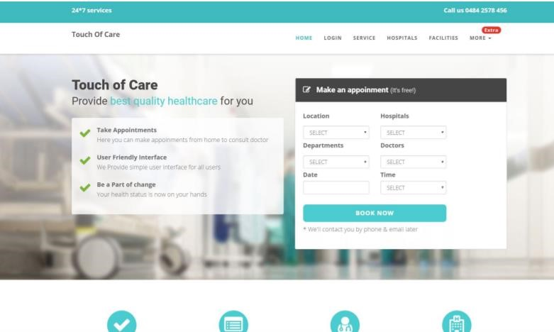

Fig.5.1. Homepage

*Computer Science and Engineering* 33 *KMEA Engineering College*

A seen in the above screen capturing from main page a user can easily navigate to the login page where the user can login with the credentials, if the user is a new to TOC user can create an account with the quick registration that is by clicking sign up at left of login page. for patient registration an QR code is generated on successful registration completion and provided to patient for easy identification at different levels in this project. Each portal is created with the aim to make it as simple and quick so that it can be used by any people without any assistance or skill.

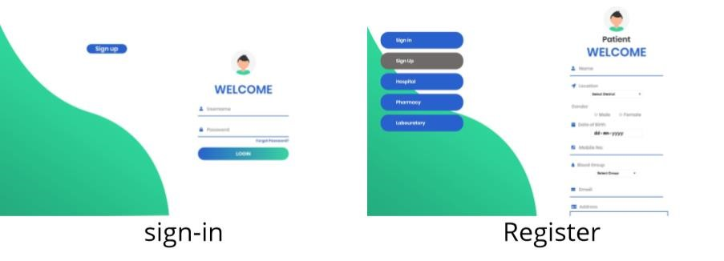

Fig.5.2. Login Page

As seen in the above page the sign in page is where the already existing user enter the details to log in to access the functionality provided by the web-application this is a universal sign in portal where both the user as well as the organizational representative such as doctor, pharmacist etc logs in. now the registration page is a simple form for better data collection that is the preliminary stage which is a key aspect when account for the health aspect. As seen in the left side of the registration portal even those health organizations that work independently can have access to the web application with the approval of the main admin such as the pharmacy which works outside the proximity of a hospital, a laboratory, nursing clinic etc.

Once the registration is complete with the pharmacy or laboratory even nursing clinics that this outside the premises of an organization the request is sent to the main admin where main admin can approve them after verification of the proper documents with the mandatory protocol.

*Computer Science and Engineering* 34 *KMEA Engineering College*

further procedure these individual organizations are approved and an email is sent to the register

account approving the usage of web application. Once this notification is received these organizations are part of Touch of Care where they can manage their organization easily.

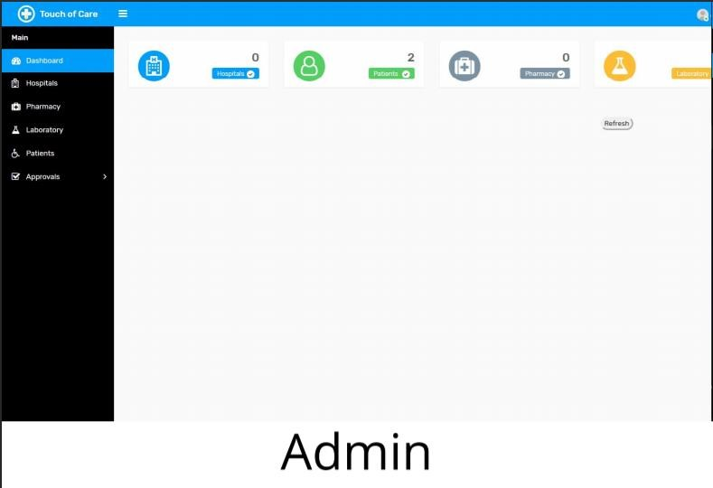

## Fig.5.3. Admin Portal

Above screen capturing are the user interface for the main admin. Admins are those who have the privilege to make changes in the main database they can retrieve any information, update information, remove information, and they can even check the current status and control the entire database. They are the one who authorize the staffs. admin can add sub-admins. They give approval for lab, pharmacy and hospital by checking the suitable documents. They can also add external lab and pharmacy.

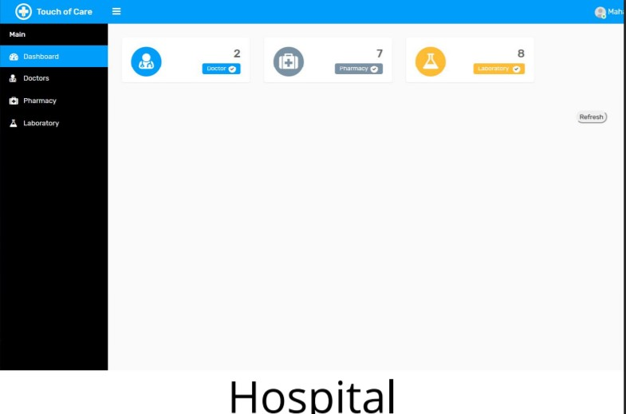

Fig.5.4. Hospital Portal

*Computer Science and Engineering* 35 *KMEA Engineering College*

Above screen capturing are the user interface for the hospital. Hospital/Sub-admin have a blank cheque to indicate their doctor, pharmacy and laboratories within the proximity of their hospital personally within their portal. Since hospital is a sub-admin here they also can have a sorted appointment to reduce the visual difficulty to have a smooth appointment list for the dynamic environment.

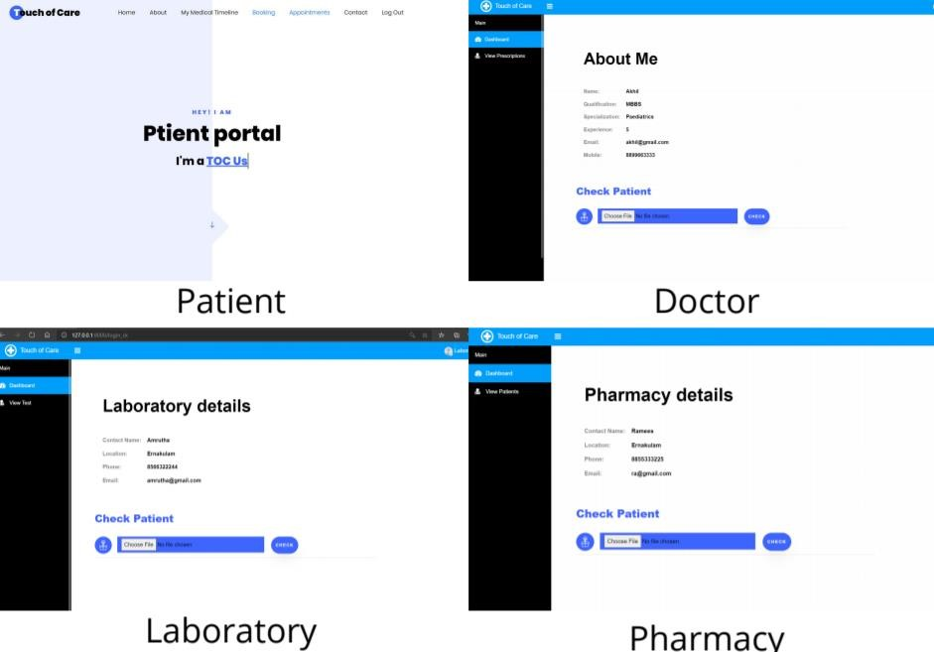

Fig.5.5. Patient Portal

Above screen shots shows the portal of patient, doctor, laboratory and pharmacy respectively. As seen in the screen shot doctor, laboratory and pharmacy have a scanning button to scan the QR code. When a patient register, they receive a QR code which is unique for each individual. They can use their profile and book their OP ticket after which they will be provided with an estimate time to reach hospital. People who come directly to hospitals can use there QR code to generate their OP ticket quickly. All process is through QR code, so easily identification is possible

*Computer Science and Engineering* 36 *KMEA Engineering College*

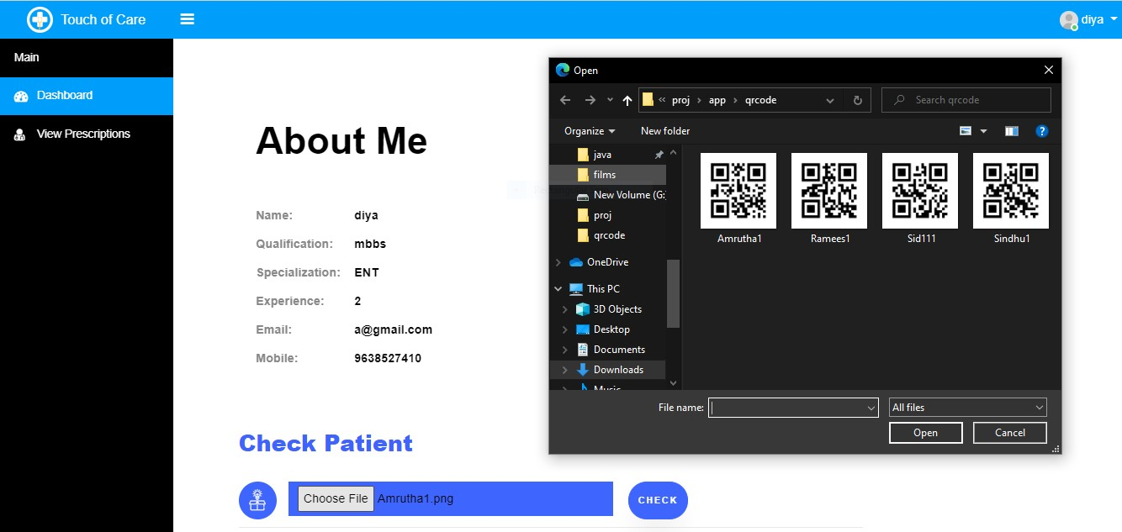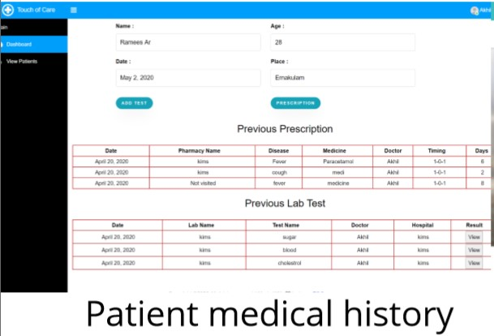

Fig.5.6. QR code display

Once the patient enters the doctors room, doctors can access the patient information by scanning the unique QR code of the patient. After which doctors are able to see the medical history of the candidates/patient as seen in the above screen shot there are two options add test and prescription. Add test is used to recommend laboratory test if required and prescription button is used to prescribe medications to purchase at the pharmacy.

*Computer Science and Engineering* 37 *KMEA Engineering College*

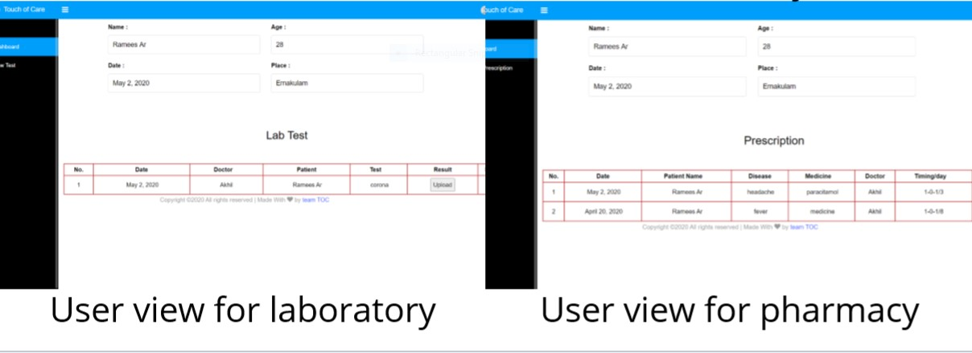

Fig.5.7. User-view

Prescription by the doctor is saved in the patient database and the relevant information is visible to the pharmacy and laboratory. here also identify the patient is done by the QR code scanning after which the medicines/lab result is provided to the patient’s database as seen in the above image. For laboratory and pharmacy only prescribed medical information is visible the entire medical history is cannot be accessed/viewed by them.

When a patient visit a laboratory if that patient is recommended to take some test at the lab this specific test that the doctor recommended can only be seen by the lab employee hence the test sample is taken and after the proper analysis an digital form of the result that maybe in the form of PDF can be uploaded in to patient data base and once the entire upload is done the lab employee can click the release that confirms the entire result is completely uploaded and this can be viewed by patient in their profile in previous lab history.

Similarly, in the case of pharmacy also once the pharmacist can only see the current prescription and after providing it to the patient the information is stored into the database of the patient and they can view it form their profile.

patients can see their medical history with a view similar to that of doctors have that is in a reverse chronological order which helps each individual to have a proper medical awareness to them self and be more conscious towards their health leading to a healthy life style.

*Computer Science and Engineering* 38 *KMEA Engineering College*

## 5.1. TESTING

The Test Plan is designed to prescribe the scope, approach, resources, and all testing activities of project TOC. The plan identifies the items, features, the types of testing to be performed.

# Scope

|  |  |
| --- | --- |
| **Module Name** | **Description** |
| **Module1 – Admin** | Admins are those who have the privilege to make changes in the main database they can retrieve any information, update information, remove information, and they can even check the current status and control the entire database. |
| **Module1 – Sub Admin** | Sub Admin are those who have the privilege to add hospitals, laboratories, doctors in the hospital and can control the appointment, and manage the data of that hospital. |
| **Module1 – Patient** | Patients can book an appointment, view their medical history, QR code is provided to new registrations |
| **Module1 –Doctor** | Doctor should be able to identify patient with QR code, they can view patient medical history and can prescribe medications ,recommend test . |
| **Module1 – Laboratories** | Laboratories can identify patients using QR code and they should be able to see the recommended test by the doctor and upload the result. |
| **Module1 - Pharmacy** | Pharmacy can identify patients using QR code and they should be able to see the prescription provided by the doctor. |

Tab.5.1. Scope

*Computer Science and Engineering* 39 *KMEA Engineering College*

These features are not being tested because they are not included in the software requirement specs

* User Interfaces
* Hardware Interfaces
* Software Interfaces
* Database logical
* Communications Interfaces
* Website Security and Performance

The test objectives are to verify the Functionality of Web Application Touch Of Care, the project should focus on testing the Generation of QR code, making appointment, viewing medical history etc. to guarantee all these operations can work normally in real working environment.

|  |  |
| --- | --- |
| **Level** | **Description** |
| **Individual Testing** | Test each individual module separately. |
| **Integrated testing** | Combine all the modules and test . |
| **System testing** | Evaluate the end-to-end system specifications. |
| **API testing** | Check the functionality, reliability, performance, and security of the programming interfaces. |

Tab.5.2. Testing Level Description

*Computer Science and Engineering* 40 *KMEA Engineering College*

**5.1.1. Test Methodology:**

Agile

As the complexity of software development process is increasing continuously, the software testing approaches needs to evolve to keep up with the development approaches. Agile testing is a new age approach which focuses on testing smarter rather than putting a lot of efforts yet it delivers high-quality products.

The testers and developers need a higher level of collaboration in Agile Testing. The testers have to provide corrective feedback to the development team during the development cycle. This is the age of on-going integration between testing and development approaches.

Agile testing is a software testing process that follows the principles of agile software development. Agile testing aligns with iterative Development Methodology in which requirements develop gradually from customers and testing teams. The development is aligned with customer requirements.

**5.1.2. Suspension Criteria and Resumption Requirements:**

If the team members report that there are 40% of test cases failed, suspend testing until the development section fixes all the failed cases.

**5.1.3. Test Completeness:**

* Specifies the criteria that denote a successful completion of a test phase
* Run rate is mandatory to be 100% unless a clear reason is given. • Pass rate is 80%, achieving the pass rate is mandatory

*Computer Science and Engineering* 41 *KMEA Engineering College*

Project task and estimation and schedule

|  |  |
| --- | --- |
| **Task** | **Estimated effort** |
| **Create the test specification** | 150 man-hour |
| **Perform Test Execution** | 90 man-hour |
| **Test Report** | 50 man-hour |
| **Test Delivery** | 20 man-hour |
| **Total** | 310 man-hour |

Tab.5.3. Project Task Estimation

**5.1.4. Resource & Environment Needs**

1. Testing Tools

No specific tools are used for testing purposes since agile method was used the issue were noted down in a document and prioritised immediately in the priority backlog and this backlog was common reference to the team if the issue is solved the priority backlog is immediately updated on the spot . in the retrospective discussion the web app was checked with multiple cases to optimise it and simplify the functions.

1. Test Environment

The testing environment is basically the pc with the hardware and software requirement mentioned above this report. We use a system with minimum of 2gb ram and 300 gb hard drive with all needed software to run it smoothly. Some software which we use to edit the codes:

2.1 Notepad++

Notepad++ is a text and source code editor for use with Microsoft Windows. It supports tabbed editing, which allows working with multiple open files in a single window. The project's name comes from the C increment operator. Notepad++ is distributed as free software.

*Computer Science and Engineering* 42 *KMEA Engineering College*

2.2 IDLE (Integrated Development Environment)

IDLE is an integrated development environment for Python, which has been bundled with the default implementation of the language since 1.5.2b1. It is packaged as an optional part of the Python packaging with many Linux distributions. It is completely written in Python and the Tkinter GUI toolkit.

IDLE is intended to be a simple IDE and suitable for beginners, especially in an educational environment. To that end, it is cross-platform, and avoids feature clutter.

**5.1.5. Terms/Acronyms:**

|  |  |
| --- | --- |
| **TERM/ACRONYM** | **DEFINITION** |
| **QR** | Quick response |
| **UI** | User interface |
| **API** | Application programme interface |

Tab.5.4. Terms/ Acronym

Some Issues came across:

A strong password and user name provides essential protection from fraud and identity theft. One of the most common ways that anyone can break into computers is by guessing the passwords. Simple and commonly used ones enable intruders to easily access and control of your account. Hence the first testing issue noticed was the simple registration with no guideline for the user name or password which was cleared by providing a security pattern as a guideline to provide better security. If the username and password is not up to the guidelines a popup message comes to direct as seen in below image.

*Computer Science and Engineering* 43 *KMEA Engineering College*

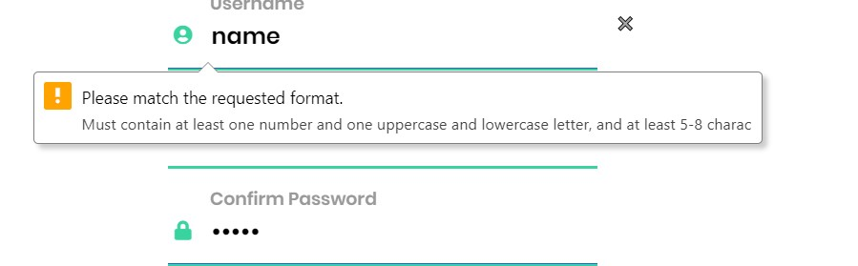

Fig.5.8. Test Issue 1

Next was the issue was noted in the calling of each pages when going through the ui. the urls provided to invoke the functions scripted in the views were not routing to the proper path hence the issue was in the naming of each urls. to overcome this issue, the naming of each urls were made distinct as seen in bellow fig due to which Django can easily route.

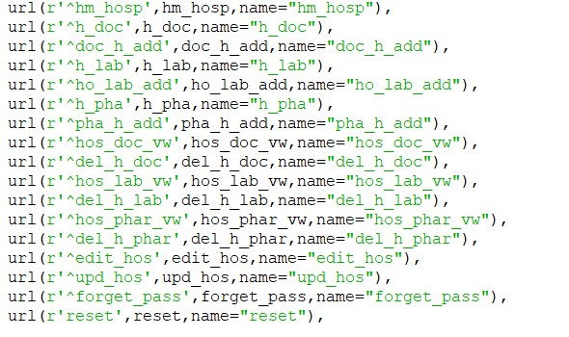

Fig.5.9. Test Issue 2

Next issue noted was with the notification system that is the host email was not functioning in different hardware set up due to the default security that each email service provides guarantees. this issue was overcome by dedicating a low secure host email for the project touch of care alone

*Computer Science and Engineering* 44 *KMEA Engineering College*

and lowering the security in the setting of the email service provider solved the issue in working with any hardware set up ideal for the project as seen in the below image.

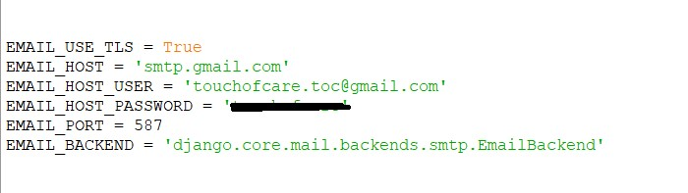

Fig.5.10. Test Issue 3

Some minor issue that was noted is was during the registration form related to the mobile phone and email details the issue was that any number could be entered into the mobile number space in order to have a fuelled form to have a proper valid mobile number a pattern was given in the form of html so that the user give the right information that is useful further as seen in below image.



Fig.5.11. Test Issue 4

*Computer Science and Engineering* 45 *KMEA Engineering College*

**CHAPTER 6**

# CONCLUSION

This project is perfect for the dynamic environment of a healthcare service providers cutting down the managing time that usually requires a manpower and high cost. This project helps in reducing the crowd that usually happen in such environment which is convenient for both patient as well as organisation. This project is done in Django which is perfect for such huge database and can be quickly modified according to the requirement without any expertise. As a conclusion our web based portal can be a centralize source of information which can contribute to our greater human evolution in the far future where all the medical amenities work in harmony in serving human raise for a challenging

*Computer Science and Engineering* 46 *KMEA Engineering College*

**REFERENCES**

**[1].** Cook, M.R. and Maiden, N., 2010. Creative requirements conversations. Software IEEE journals &Magazines, Vol.27, Issue 2, pp. 90-91.

**[2].** Ilaria Baffo, Giuseppe Stecca, and Toshiya Kaihara, "A multi agent system approach for hospital's drugs management using combinatorial auctions", IEEE International Conference on Industrial Informatics-INDIN, pp. 945-949, 2010.

**[3].** Jung Insung, Thapa Devinder, and Wang Gi-Nam, 2007. Intelligent Agent Based Graphic User Interface (GUI) for e-Physician, Proceedings of the World Academy of Science, Engineering and Technology 2007, pp.194-197.

**[4].** Kushwaha, N., Sahu, S. and Ahmed, P. March 2012. Gathering Requirements for Hospital Management System Using Intelligent Agents. International Journal of Engineering and Innovative Technology (IJEIT), Vol.1, Issue 3, pp. 276-279.

**[5].** Moore, J. Michael and Shipman III, Frank M., 2000. A Comparison of Questionnaire-Based and GUI-Based Requirements Gathering. Proceedings of the 15th IEEE International Conference on Automated Software Engineering 2000, pp.35-43.

**[6].** Tveit, A. 2001. A survey of agent-oriented software engineering, Proceedings of the first NTNU Computer Science Graduate Student Conference, Norwegian University of Science and Technology, 2001, May, pp. 1-8.

**[7].**Yang Hongqiao, Liu Xihua, Wu Fei and Li Weizi, "Multi-agent based modeling and simulation of complex System in Hospital", in Proc. Sixteenth Int. Conference on Industrial Engineering and Engineering Management, pp. 1759-1763, 2009.

*Computer Science and Engineering* 47 *KMEA Engineering College*

# PUBLICATION